**CDAC Feb 2015**

Sequential Multiplier

Name: Bhrigu Bhargava

**Sequential Multiplier**

# Design Approach:

Sequential Multiplier is an electronic circuit used in digital electronics, to multiply two binary numbers. It is built using binary adder and other possible sequential circuits. A variety of computer arithmetic techniques can be used to implement a digital multiplier. Most techniques involve computing a set of partial products, and then summing the partial products together.

**Synthesis:**

1. RTL Schematic

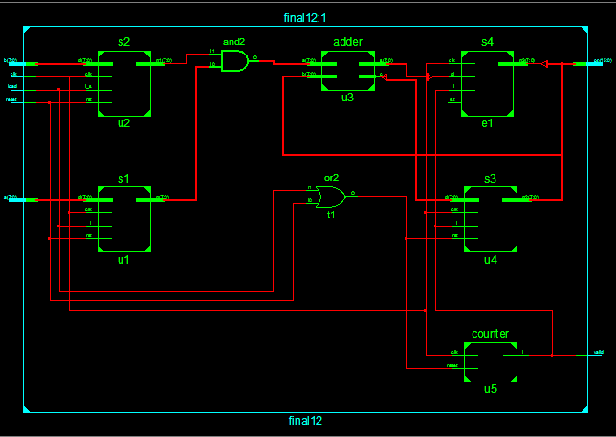

1. Block Diagram

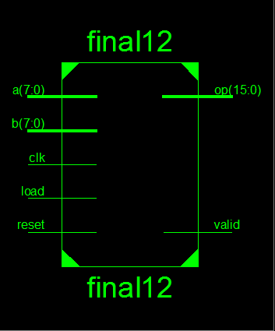

1. Tech Schematic

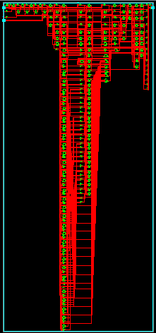

1. Simulation Waveform Result

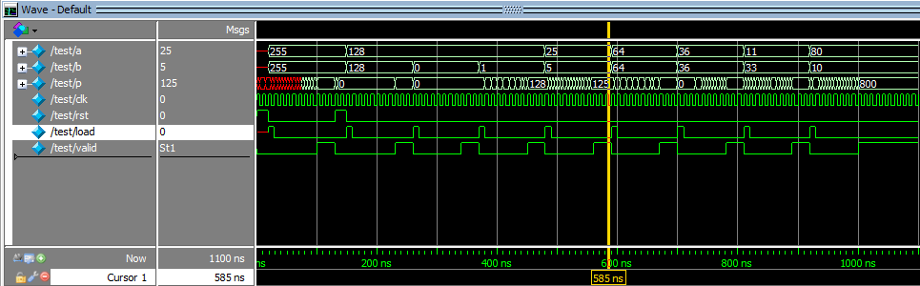

**Error:**

None

**Verified by:**

Dharamvir Chundawat (150240133007)